**LAB#7**

**Task3** Write a program to calculate the factorial of any number using while loop.

Source code

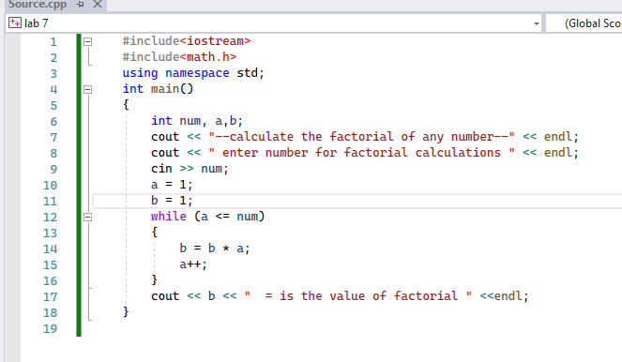

Output

